**BSc in Computing**

**Team Project & Group Dynamics Module**

***PathFinder***

**Proposal, Technical Project**

**to be presented on *21/10/2019***

***Christopher J. Costelloe K00233369,***

***Jekaterina Pavlenko K00224431,***

***Kevin Dunne K00232599***

***Project Supervisor(s)***

**Natasha Kiely, Aileen O’Mara**

# 

Contents

1. Introduction 3

1.1 Purpose 3

1.2 Background 4

1.3 Needs Statement 5

1.4 Project Scope 5

1.5 Project Members 6

2. Proposed Technical Approach 7

2.1 Requirements 7

2.2 Application mechanics 8

2.3 Prototype/Storyboard 8

2.4 Architecture Design 14

2.5 Implementation 15

2.6 Quality Assurance Plan 15

3. Expected Project Results 16

3.1 Measure Of Success 16

4. Project Management 17

4.1 Development Methodology 17

4.2 Schedule 18

4.3 Budget 19

4.4 Communication & Collaboration Plan 19

5. References: 21

6. Appendices: 22

# Introduction

## Purpose

This project aims to create an indoor navigation application which can be used in any area, be it a building or outdoor area. The product should be able to show you your location and show you a path, along with any information on the destination you have selected to go to.

This project is looking at using Bluetooth beacons, NFC tags, Barcodes and QR codes. The idea is that the project is not reliant on just one form of technology but will use many technologies to solve a navigation issues for people, in either buildings or outdoor areas. Building could be hospitals, colleges, museums, while outdoor areas could be pet farms, tourist attractions, walking trails, etc.

Since navigation can be done just using barcodes or QR codes, the main cost would be printing off unique codes, laminating the sheets and then placing them where required. This means users can scan the codes to receive information on where they are and what is there. If Bluetooth beacons or NFC tags are used, then this automates more of the application in that the user does not have to manually scan something but can instead just tap an NFC tag, or the app can detect the beacon, and then show the user where they are.

This will benefit anyone who routinely goes into large buildings like hospitals or colleges. Most verbal instructions can lead a person into somewhere they were not intending to go back to where they started as there is such an extraordinary number of corridors and rooms within these buildings, it is very easy to get lost. This application will help solve that problem by offering a means to finding out where you are, with instructions on how to get you to your destination.

The basic idea is that each entrance will have a unique code assigned to it. Getting this code into the application will be done either by Bluetooth, NFC Tags, Barcodes or QR codes. The app will then download the map and way points / marked locations / destinations and allow the user to select where they would like to go. The app will then generate a list of directions for the user to follow. At any time, the user can scan, tap or be informed (via Bluetooth Beacons), where they are on their route.

## Background

As we all know, GPS can’t be used in indoor environments, because signals from satellites do not move easily through solid objects such as brick, metal, stones & wood. All these materials usually used for making buildings & make it very difficult for GPS signals pin your location accurately indoors. That’s why we need to have IPS – Indoor Positioning System, which is the next generation of positioning technology helps to beat limitations of GPS. Indoor Navigations System technologies are being developed by Google, Microsoft, Nokia etc.

We did a variety of research of current indoor GPS navigation systems on the market to better understand advantages & disadvantages of products and how we would make our system better than the existing systems on the market right now by trying to implement different solutions and also by developing a system that is lower cost than bigger companies which charge an extremely large amount of money.

There are several types of wireless technologies are used for IPS: WLAN, Wireless Bluetooth techniques, Infrared (IR) techniques, Ultrasound techniques, Ultra-wideband (UWB), Ultrasonic system & Cellular based techniques. <https://www.hindawi.com/journals/js/2017/2630413/>

Infsoft company from Germany, which provides leading indoor GPS navigation products such as Indoor Positioning, Tracking & Analytics solutions for businesses, is used to map out warehouses, to track in which zones of store customers spent most of the time for future store optimization & to guide automated vehicles in the same warehouses.

It is really useful to have indoor navigation system in big buildings, where people usually struggle to find their way and because it will save time and nerves.

*New plan for this chapter:*

* *~~GPS technology – why we need to have separate indoor navigation system?~~*
* *What companies used before & now? (technologies & techniques)*
* *~~Advantages & disadvantages of using indoor navigation system?~~*
* *List about 3 best indoor navigation systems offering companies, what products they are offering. Technologies used & pricing*

## Needs Statement

This project aims to create an indoor navigation map for any building using an extremely low cut budget but will be able to deliver an effective and easy to use application, most businesses who offer the same type of application charge an incredible amount of money which is why most businesses who could use this application would never buy it.

The idea behind this app is to make something that is simple to use, simple to maintain and update, and easy for everybody to work with. Due to this, we are focusing on cost as one of the main targets for the project and this is being achieved by using Barcodes and QR codes, which can be easily generated and printed off.

Due to the low cost of implementing this solution, it is envisaged that large buildings that are constantly being used by the public, that there curators would see the advantage of having a system in place that would show to the user, where they are, where they can go and how that can get there, would reduce the number of enquiries from the public to staff, on how to get to places within the structure.

## Project Scope

**Goals:**

The Product scope requires a website that organizations can register and log onto, they will be able to upload, delete, and edit new Maps of their buildings with information on each checkpoint.

The product scope also requires a database that will store information on both the website and application and the ability to manipulate both from each..

The product scope for the application requires that the user will be able to use our application to download a map from any listed buildings, the user will scan a QR code to check their current location, this will be a checkpoint, the user will then select another checkpoint on the map and an icon or waypoint will be displayed to them to guide them to their destination.

**Project Scope**

**Cost:**

The cost involved in our project will be 100 euro to buy the NF, Bluetooth beacons that we will use in our project.

**Deadlines:**

Our deadline and roles have been laid out in our Gantt chart, which display all features and their breakdown and including the manhour’s each section will take.

## Project Members

|  |  |  |  |
| --- | --- | --- | --- |
| **Team Member** | **Role** | **Contact Information** | **Responsibilities** |
| Kevin Dunne | Champion /  Developer | K00232599@student.lit.ie | Back End Database, research, Literature Review, Web based design, Web front-end, App Development |
| Christopher Costelloe | Developer | K00233369@student.lit.ie | Web based design, Web front-end, App Development |
| Jekaterina Pavlenko | Designer /  Developer | K00224431@student.lit.ie | Database, Web based design, Web front-end, App Development |

# Proposed Technical Approach

## Requirements

In order to implement this system, we are looking at;

* Azure Hosting of the Database.
* Web Hosting for the users / companies – show info on the production for users and to allow companies to upload their data and waypoints.
* Android App will be the main user interface and will consist of
  + Landing screen with information about application.
  + Ability to capture where the user is and what maps / waypoints are needed.
  + Allows user to select where they need to go using a dropdown or icon on the map.
  + Show instructions on “how to get there” form where the user currently is using an icon or text popups.
  + (Optional) Message to inform user when they have reached their Destination and potentially display information on their destination.

This is a high level diagram (at Figure number shown below) showing cloud with database server, linked to a network (for users to check in at home / companies to upload data), business place/college/hospital and user connecting to database to get required details to find the route to where they need to go.

*Figure 1. System architecture/topology.*

## Application mechanics

The proposed solution has two different interfaces for the users and the companies. In the storyboard below, both are shown.

The web site will allow the user to preview what the application can do. For business, there is an option to register to use the application / database. This will be used to contact the company and setup required information. Companies, once approved, can then login and setup their maps and waypoints. A “Contact Us” page will be available for all general enquiries on the application.

For the Android Application, one launched, the user will have simple instructions on how to use the app. The user then obtains the company information (maps and waypoints) by either Bluetooth, NFC tags, barcodes or QR codes. Once done the map is then presented to the user with a drop-down allowing the user to select where they would like to go. The list of instructions is then generated and show to the user. The user can obtain updates along the way, either by Bluetooth, NFC tags or by scanning other Barcodes and QR codes.

## Prototype/Storyboard

*Figure 2. Landing Page.*

This is the webpage for the user/organization so that they are introduced to our application and contains essential information about our product and what to do.

*Figure 3. Registration Page.*

This is the web page that the organization must fill up and submit to the creators of the application so that their organization is registered and can then use our application.

*Figure 4. Login Page.*

The login web page for the organization/user.

*Figure 5. Maps uploading page.*

This is the Maps section of our website which allows the organization to upload/edit and delete their maps.

*Figure 6. Android application landing page.*

This is the instructions that will be displayed to the user to help them understand how to use our application.

*Figure 7. Android application QR codes scanner.*

This will be the layout of the application when it needs to scan a QR code to find out the current location inside a building.

*Figure 8. Downloading maps after scan.*

This is the layout when a map has been successfully downloaded from our database and displayed to the user.

*Figure 9. Route display.*

This is the map of a building with different points on the map that the user can select.

*Figure 10. Moving at this route.*

This is the map being updated with the user's current location.

*Figure 11. Moving to destination.*

This is a display of the user’s current location.

*Figure 12. Reaching the destination.*

This is the display on the map when the User has reached their current destination.

## Architecture Design

We will be using Azure hosting as this is what research has shown best suits our current requirements. This hosting will be for the database and the website. This is one half of our solution and the other will make use of Android phones / tablets.

We are not considering the Apple systems at this point in time, as there is insufficient project time available to support two App developments.

Bluetooth beacons and NFC tags will be supported so that the application can be more automated and easier for the users of the application.

Barcodes and QR codes can also be used but these need to be scanned in by the user and increase the complexity of the application use. It would be easier for the user to use either Bluetooth beacons or NFC tags but all methods can be used, and all can be available for a business (mix and match approach).

*Figure 13. System architecture/topology.*

## Implementation

The Development Methodology that we has a group have decided to implement is the Sprint Agile development module, the reason we chose this methodology is because since we have started this course this is the development methodology that has been constantly praised and we have been told that this is now becoming the industry standard.

This has lead each of us to research and study the agile module over the previous years and to base the majority of our projects around this method which has now become second nature to us, this is the reason we as a group have decided to use this development methodology.

Using this Methodology enables us to do quick developments each week e.g. sprints, to show progress of the project, to test and verify what we are doing is the end requirement needed, to keep us focused on getting small bits done quickly so that the project proceeds and can be delivered in good time and to a high standard.

## Quality Assurance Plan

As the primary purpose of this software is to get a user from one point on a map to another point on the map, we have to make sure that the user is urged to follow the suggested path while taking care of their surroundings (walking on paths, crossing roads with due diligence, etc.)

In order to achieve this and ensure the quality of our software, testing of all sprint aspects must be done by all team members to ensure that there are no issues with the software, the results and the maps, instructions that are shown to the user, if the software is not of high enough quality, then the following is possible:

WEB

* Site not available for users
* Site not allowing users to login / logout
* Site not updating companies’ data correctly
* Site not responding to app API requests

Detailed testing of each sprint and the system components will ensure that the site is working and responding as needed.

Android App

* Not launching correctly
* Does not scan (barcodes or QR Codes)
* Bluetooth and / or NFC not working
* Incorrect Maps / Way Points downloaded
* Bad path to destination generated (long way instead of best way)
* App not updating correctly

Detailed testing of each sprint by all team members will ensure that we develop the app as needed and that all features work as per expectations.

# Expected Project Results

*List deliverables expected to be produced for the project*

The expected deliverables for the project are as follows;

* Working web site
  + User can find and use the web site
  + Companies can register for use of the website.
  + Companies can log into the site, update their information, map and way points and logout
  + Anybody can send on a query regarding the site and application
* Hosted Database
  + Storage of company data
  + Storage of maps
  + Storage of waypoints
* Android Application
  + Launch screen
  + Ability to capture where the user is (Bluetooth beacons, NFC tags, Barcodes, QR Codes)
  + Show maps and places user can navigate to
  + List of instructions / steps on how to get to the destination

## Measure Of Success

In order to determine the success of the project, the following goals should be achieved:

1. The User can find the web site and learn vital information about the application.
2. A Company can register with the site and have the ability to Login.
3. The Company has the ability to upload maps and select waypoints on a map.
4. The User can view company maps and waypoint/checkpoints on a browser.
5. The User can sideload the app onto a phone and use the maps and waypoint/checkpoint to get to a selected destination.

.

# Project Management

## Development Methodology

The development methodology to be used to deliver the project will be Scrum Agile – Sprints, which is time limited iterations of continuous development cycles. Sprint is a planned amount of work to be done and reviewed by team. Duration of a Sprint usually up to 2-4 weeks. To help implement this development methodology, we are going to use also Gantt’s chart and Backlog. Gantt’s chart is a visual way to track tasks across the project’s lifecycle. Using Gantt’s chart and Backlog is a helpful way to capture and plan our work.

Usually, each sprint supposed to begin from meeting planning. A person that requesting the work and development team members need to agree what will be done during that Sprint. The development team members also supposed to say how much work can be actually, realistically done during this period of time. Finally, a person, that requesting a work to be done, says what requirements need to be met for work to be approved & accepted.

A bit more detailed explanation of Scrum Agile development methodology – what is it? Scrum is a framework that has iterative approach in software development cycles & again sprints will be part of it. The scrum approach includes setting up the project’s requirements and using them to define the project. Daily scrum meetings help to keep that the project on right track by doing regular checks, reviews and inspections. Scrum teams use regular inspections on each part of the development process.

Sprints help to make projects development more flexible & manageable, and to deliver a high-quality work faster – adapting to changes happening more flexible by using sprints.

In general, the way it works - Agile is a set of rules & principles, Scrum is a framework for getting things done. The scrum values of clarity, checks and flexibility are complementary to Agile methodology and central to the concept idea of sprints.

## Schedule

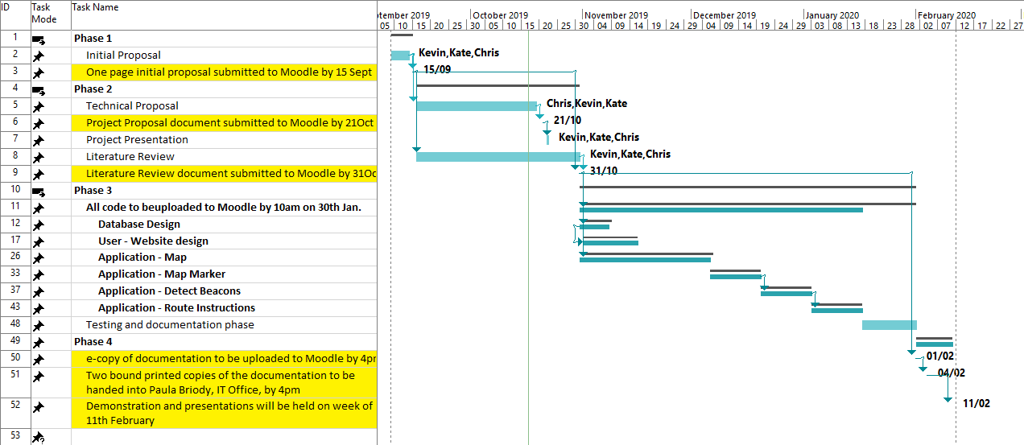

Figure Gant Chart

## Budget

*Unless there are budget considerations beyond using your own or department resources, enter “No budget required.” Otherwise include needed items.*

We need for projects: 2-3 Bluetooth beacons, ~10 NFC tags, paper sheets & ink for QR code printing. Our budget is going to be ~100 euro. All components of project we are planning to order from Amazon – free & fast delivery.

At picture below, we are going to show you Excel spreadsheet to show pricing research & calculations.

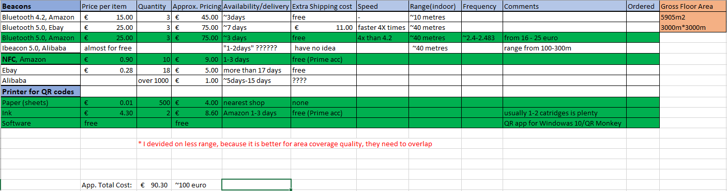

*Figure 15. Budget Excel spreadsheet.*

Green font shows to which one of the components we are going to pick, calculations of pricing each component roughly, because there are different sellers offering same product with different prices and consider as well that other version might be out of the stock.

## Communication & Collaboration Plan

Our communications will be through quick daily catchups with a formal meeting that will be held every week where the minutes of the meeting are recorded. These minutes then form a part of the next weekly meeting, allow for coherence between meetings.

We have created a GitHub account / site for the storage of all information, documentation, research and program code.

Google Docs is being used for the collaboration of any documents that are in the process of being created and worked on. This allows for many users to work on the same document at the same time.

Microsoft Project is being used the generation of our Gantt chart and this will then be used as our schedule for work.

# References:

# Appendices: